Website Project: Logo and Style Guide

# Logo

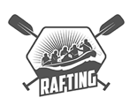

# Color Labels

* primary-color: 1E6091
* secondary-color: 34A0A4
* accent1-color: D9ED92
* accent2-color: 99D98C

# Font Labels

* heading-font: Lobster
* text-font: Clear Sans

# Coolors.co URL

<https://coolors.co/palette/d9ed92-b5e48c-99d98c-76c893-52b69a-34a0a4-168aad-1a759f-1e6091-184e77>